**MCDHH E-News: November 18, 2022**

3216 Emerald Lane, Suite B, Jefferson City

www.mcdhh.mo.gov V: (573) 526-5205; VP: (573) 298-6778

**Many thanks to the Museum for the special attention and support provided to Missouri’s endeavor to pass LEAD-K here!**

On November 12, 2022, Commission Chair, Clark Corogenes arranged a tour at the History of Deaf Culture, History and Art in Olathe, KS.  Becky Davis from MCDHH and Scott Dollar representing MoAD were also present.  The private tour was to inform legislators and several supporters of the Missouri LEAD-K legislation about the Deaf community and perspective.  Rep. Jerome Barnes and Sen. Lauren Arthur along with Dr. Julie Holland from the Parent Leadership Training Institute and their families attended the event. 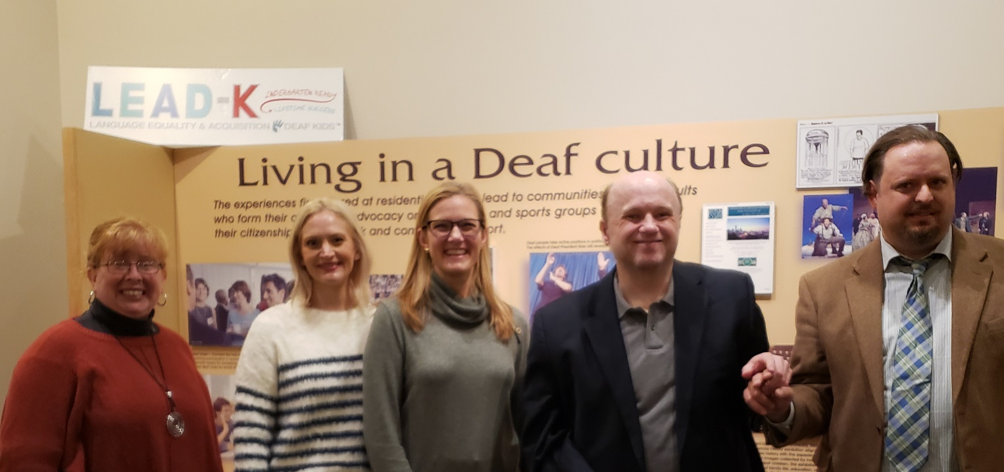

**UPDATE ON RID SPONSORSHIP STATUS:**

MCDHH submitted their plan of action to the RID Audit Committee. We are pending review. A follow up announcement will be made when a decision is determined. Thank you for your patience.

**Sleep Family Scholarship:** We are a family-run organization that offers helpful resources for individuals with sleep and wellness issues, especially as caused by physical and mental disabilities. We offer an annual $1,500 scholarship for disabled students, for more information, click here:  [https://sleepfamily.org/scholarship/](https://urldefense.com/v3/__https:/sleepfamily.org/scholarship/__;!!EErPFA7f--AJOw!Dgxi805jfN4EFR4v25lsngb-DnBed2X-f80N4XuT-ZmcvuIEdeLg58nbw5z2SkZlYY-Izc0lyFeY0OJQwA3JEEiM1pk$)

**Interpreter Certification Renewal:** Interpreters! Don’t forget that it’s time to renew your certification. Your renewal paperwork must be postmarked by December 2, 2022 in order to avoid late fees and the possibility of your certification becoming invalid. Don’t hesitate to reach out to our office if you have questions about your renewal.

**Conceal Carry Class** is being offered at Eagle Eye Shooting Range in Wentzville, MO

Saturday, December 3rd, 2022

Location: Eagle Eye Shooting Range and Gun Shop - 851 Pic Parkway  Wentzville, MO.  63385

Cost: $125

Length of time: 8 hours long from 9am to 5pm with lunch provided.  (Please arrive to class 15 minutes early)

40 rounds of ammunition is required with a handgun. (If you do not have a handgun and ammunition, this can be rented and purchased through the shop)

Registration can be called in to Eagle Eye USA at (636)-887-4867. (Pre-registration is required) **\*\*Interpreters will be provided\***



**JOB ANNOUNCEMENTS:**

**DEAF, Inc**. is looking for a Finance Manager who is an experienced & finance-savvy manager who’s equally as eager to join our team and passionate about accessibility. This position is in St. Louis, MO. See below and our website for more information about the position!

[https://www.deafinc.org/about.html#careers](https://urldefense.com/v3/__https:/www.deafinc.org/about.html?fbclid=IwAR3CojtCo3-SkHEMf97qtNqsLU9NGQ7KumQWBe1KaszUGMX5wqQCvQ_srio*careers__;Iw!!EErPFA7f--AJOw!Hrlh_yvfKDDFZPOHdTr9M4A-uP-p6hxK2WggMYBQDu_8SqgVkIecXdRGhDvOAcBet5rQ14FEHCw9R-J83WFTg9t1$)

**Join the MCDHH Team: Now Hiring a Hard of Hearing Program Manager**

Are you looking for an opportunity to work in a highly visible and respected state agency? Do you have what it takes to blend with a creative, talented, and innovative team? This may be the job for you! MCDHH is currently looking for applicants to fill the position of **Hard of Hearing Program Manager**. Learn more and apply Hard of Hearing Program Manager.

**Job Posting at Springfield Public Schools (MO)**

[2022-2023 Educational Interpreter, ASL - Special Education](https://urldefense.com/v3/__https:/spsmo.tedk12.com/hire/viewjob.aspx?jobid=3252__;!!EErPFA7f--AJOw!HqEehHZtRuRxnSehcK--HXYnesmsFLlnnC62RqS6yOuKmUv2k0Ny2DqJMwIgj-xUzZxGs5yuBgQrq4x_UUNyvYJ_Wf24l_uaPaql2g$)

**Job Title:                        Educational Interpreter**

**Department:**                  Special Education Services

**Pay Grade:**                     O251

**FLSA Status**:                  Non-Exempt

**Reports to:**Assistant Director III – Special Services

**QUALIFICATIONS AND REQUIREMENTS**

Education and Experience

* Targeted, job related education with study in job-related area.
* Job related experience is required.
* Certificates, Licenses and Other Special Requirements
* Must have and maintain certification through Missouri Commission for the Deaf and Hard of Hearing
* Must have and maintain licensure through State of Missouri Division of Professional Registration as an Interpreter
* Must pass a Criminal Background Clearance, the results of which must be satisfactory to the District, required.

**Interpretek** is looking for dedicated interpreters and Employees. For more information, click here: https://fb.watch/f3oasFGxal/





Better TOGETHER – MT & A is Looking for YOU! We are looking for a Staff Sign Language Interpreter and a Contract Sign Language Interpreter – {St. Louis Metro & Surrounding Areas}. To apply via Indeed for the FT Position or mtapractice/recruiting.com for Contract Position.

