MCDHH E-News: September 23, 2022
3216 Emerald Lane, Suite B, Jefferson City
www.mcdhh.mo.gov V: (573) 526-5205; VP: (573) 298-6778

29th Annual Missouri Interpreter Conference – October 7 -9, 2022 will be held at Tan Tar A Resort (Margaritaville) in Lake Ozark, MO. Come join us for a weekend of workshops, Illusions Show, fellowship and fun! The conference begins on Friday, October 7 with our Keynote Speaker, Kevin Richmond at 7:00 p.m. Student conference begins on Friday, October 7 at 10 a.m. This is open to all ITP students and those that have graduated within the past year.
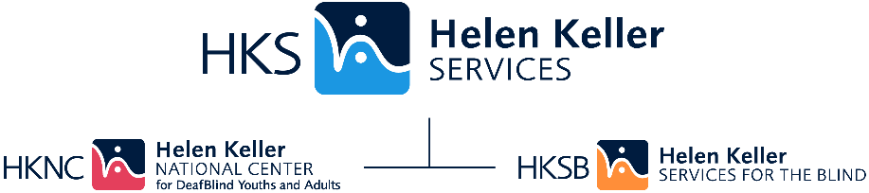

Helen Keller Services is Celebrating its 3rd annual National Disability Employment Awareness Month (NDEAM)! Join us for a FREE WEBINAR on October 5th at 1PM CST, airing nationwide.
#NDEAM ASL Invitation
The US Department of Labor's theme for NDEAM 2022, "Disability: Part of the Equity Equation," recognizes the vital role people with disabilities play in making the nation's workforce diverse and inclusive.
A renowned speaker and panel of experts will share their experiences, best practices and outlook of the inclusion and employment of individuals with disabilities, including those with vision and/or hearing loss.
The Governor’s Council on Disability (GCD) is now accepting applications for the Leadership Development Program for Deaf/Hard of Hearing. Applications must be submitted by September 30, 2022.

The Leadership Development Program for Deaf/Hard of Hearing (LDP) is a 3-day career leadership training program for high school students who are deaf/hard of hearing, ages 16 – 21 to learn about leadership, mentorship and career development skills.

The LDP will be held November 4-6, 2022 at the Missouri School for the Deaf in Fulton. Missouri high school students who are deaf or hard of hearing are eligible to participate. The student delegates will represent a cross section of Missouri in terms of geography, gender, economic status, ethnicity and different types of disabilities.
Knowledge of American Sign Language is not required for students to apply.

The Leadership Development Program is hosted by the Governor's Council on Disability in collaboration with Missouri Commission for the Deaf and Hard of Hearing,
Missouri School for the Deaf, MU-Pre-Employment Transition Services, Paraquad and Vocational Rehabilitation.

To find out more about the LDP and apply online, visit https://disability.mo.gov/gcd/LDPDHH.htm
For questions about the LDP, please contact the GCD at 573-751-2600.
Please share this opportunity with students, parents, teachers, and colleagues.

Missouri Council for the Blind is hosting a “Special Event” on September 25, 2022 from 5:30 p.m. to 8:30 p.m. at the Missouri Council of the Blind located at 5453 Chippewa St. St. Louis, MO 63109. “Come meet PT trainers: John Lee Clark, Hayley Broadway, Roberto Cabrara and Jason Herbers”. Learn more about PT and socialize with your community. Vancro Program Specialists will be there too! *Please be respectful of the PT space. Very limited interpretation will be provided.

Parent Leadership Training Institute KC @pltikc is committed to investing in #ParentsWhoLead, so they are fully equipped to create transformational change in
their homes, schools, neighborhoods, and public policy. Past cohorts testified before elected bodies, lead PTAs, served on boards, wrote Op-Ed pieces, and started new
initiatives to improve outcomes for children across the city. Join a community of changemakers and apply for PLTI: https://www.pltikc.org/how-to-join

JOB ANNOUNCEMENTS:
Interpretek is looking for dedicated interpreters and Employees. For more information, click here: https://fb.watch/f3oasFGxal/

