MCDHH E-News: August 12, 2022
3216 Emerald Lane, Suite B, Jefferson City
www.mcdhh.mo.gov V: (573) 526-5205; VP: (573) 298-6778

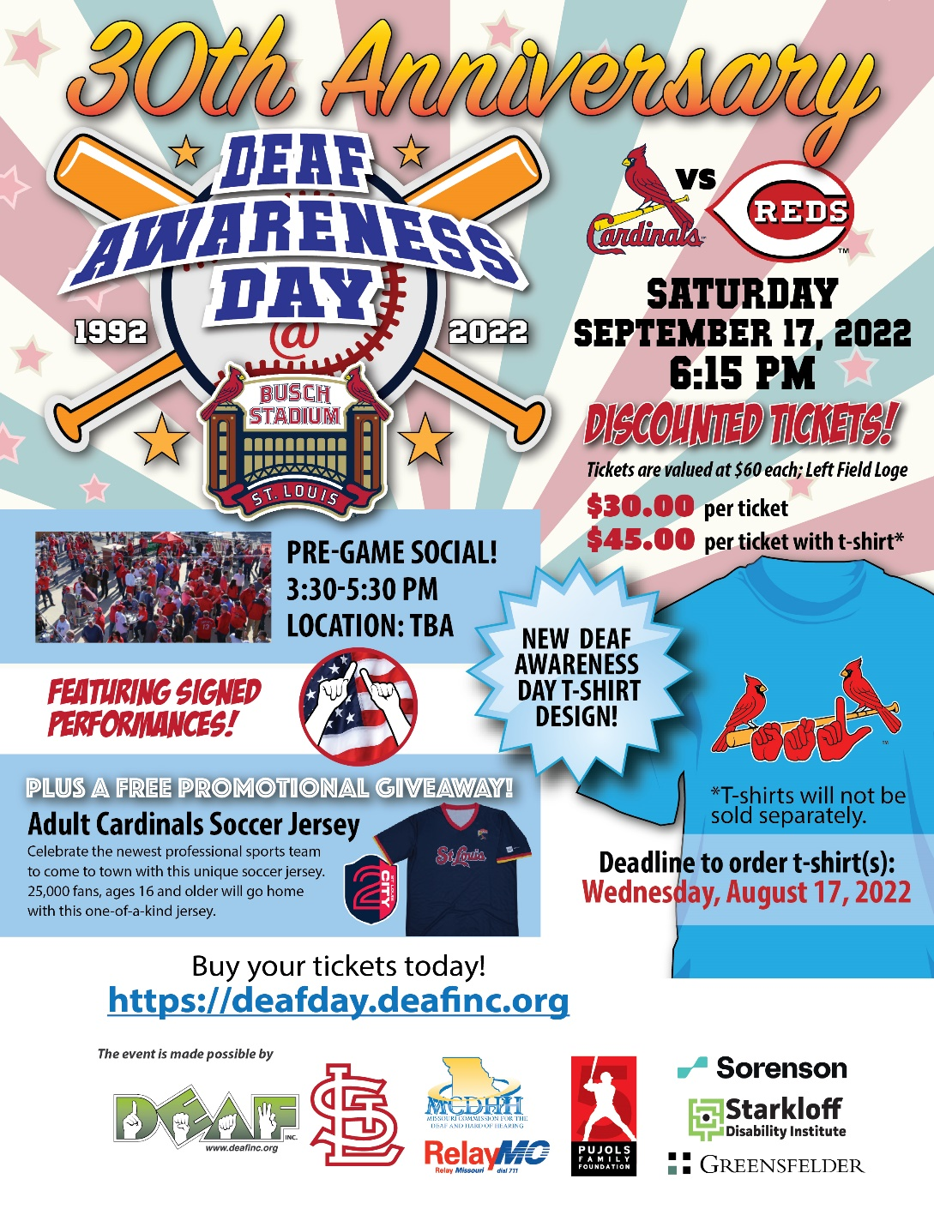
Deaf, Inc. is sponsoring the 30th Anniversary Deaf Awareness Day at Busch Stadium. Come and see the St. Louis Cardinals vs the Reds on Saturday, September 17, 2022 starting at 6:15 p.m. Discounted tickets will be available at the left field Loge.
Deadline to order t-shirt(s) is Wednesday, August 17, 2022.
A pre-game social will be held from 3:30 – 5:30 p.m. Location TBA.
There will be signed performances during the game.

Parent Leadership Training Institute KC @pltikc is committed to investing in #ParentsWhoLead, so they are fully equipped to create transformational change in their homes, schools, neighborhoods, and public policy. Past cohorts testified before elected bodies, lead PTAs, served on boards, wrote Op-Ed pieces, and started new

initiatives to improve outcomes for children across the city. Join a community of changemakers and apply for PLTI: https://www.pltikc.org/how-to-join

BEI Testing
MCDHH is still actively proctoring both TEP and BEI performance exams.
BEI Test results are between 60-90 days. MCDHH is actively working on getting all testers their results as soon as possible and ensuring compliance with all State of Missouri, and the State of Texas standards.
All testers will be notified by MCDHH when results are ready. Please do not contact Texas for your exam results, as they do not have any information to provide.
Silver Dollar City Deaf and Hard of Hearing Awareness Day will be August 20, 2022. Plan to stop by the MCDHH table to pick up the interpreting schedule and to register for a free event shirt.

TEP Group Testing is being offered at Conference
MCDHH will be offering limited group TEP (Test of English Proficiency) sessions at the 29th Annual Interpreter Conference at the beautiful Tan Tar A Lake Resort- Margaritaville. Group sessions will be held at Saturday, October 8 from 1:30 p.m. – 3:00 p.m. and on Sunday, October 9 from 8:30 a.m. to 10:00 a.m. If you would like to test in one of these group sessions, please submit your paperwork and appropriate fees to MCDHH at 3216 Emerald Lane, Suite B, Jefferson City, MO 65109. Please mark on the top of your application your first and second choice of testing times. Staff will take your options into consideration, but the Saturday session will be full before we offer the Sunday session. Your paperwork must be received no later than September

9, 2022 to be considered for testing. The required paperwork can be found on the MCDHH.mo.gov website under the certification tab. If you have any questions or concerns, contact Laurie Lister at Laurie.Lister@mcdhh.mo.gov or call (573) 522-1859.

Title: Deaf and DeafBlind Oppressions Workshop - This event is FREE for Vancro Integrated Interpreting Services interpreters and, with the goal of promoting equity and
inclusion for underserved communities, this event is also FREE for members of the Deaf and DeafBlind communities. General attendance to others for this event is $15.

Date: August 27, 2022
Time: 8am-10am PDT/10am-12pm CDT/11am-1pm EDT
Location: Online via Zoom
Presenter: Hunta Williams
Register Here: https://airtable.com/shrd9QIQZJ2BLMQCg

Research Study by a doctoral student at Northcentral University about your hearing experiences and the use of technology in your online course. Participation in this study will receive a $25 Amazon gift card to Amazon via Qualtrics online after completing the questionnaire. If you are interested in participating in this study, please click on the Qualtrics link: https://ncu.co1.qualtrics.com/jfe/form/SV_3kLCAdAoRSNsRM2
Please email or text t.lachapelle8386@o365.ncu.edu (860-420-2036) with any questions.

The Governor’s Council on Disability is accepting entries for the annual GCD Disability Employment Awareness Month Poster Contest now through August 15.
Don’t delay – start submitting your posters now.
The Governor’s Council on Disability’s (GCD) annual poster contest raises awareness about the importance of employment for people with disabilities. National Disability

Employment Awareness Month (NDEAM) is observed each year in October to celebrate the contributions of workers with disabilities and educate about the value of a workforce inclusive of their skills and talents.

The posters are intended to spark a conversation about employment of people with disabilities and raise awareness about the importance of inclusion in the workplace. The winning entry will be featured on this year’s Disability Employment Awareness Month poster, GCD’s website and social media. Start working on your posters now!

Illustrate the importance of workforce inclusion through your artwork. Why is employment inclusion important to you? What does employment mean to you?
For more information, visit
https://disability.mo.gov/gcd/PosterContest/

Child Protective Services and ASL Interpreter Webinars will offered in June, July and August. To receive full credit, you will need to attend all three sessions offered each month. For more information, click here on the monthly links August - August CPS Courses

SHOW ME SUMMIT ON AGING & HEALTH 2022 We Are BETTER TOGETHER! SHOW ME SUMMIT ON AGING & HEALTH 2022 September 12-14, Kansas City, MO

Present the JOINT 17th Show Me Summit and the 7th Age Positive
Conference September 12-14 | Fully in person at the Intercontinental Kansas City on the Plaza. For more information, click here: Show Me Summit

MCDHH at the 2022 Missouri State Fair
MCDHH will have a booth at the Missouri State Fair in Sedalia on Thursday, August 18, 2022 from 9 a.m. until 6 p.m. We hope to see you there!

JOB ANNOUNCEMENTS
Springfield Public Schools is looking for an Educational Interpreter, ASL for the 2022 – 2023 school year. For more information, click her: Educational Interpreter - ASL
Special School District’s Deaf and Hard of Hearing Program is recruiting qualified candidates for the following positions for the 22-23 school year:
Teacher of the Deaf
Paraprofessional/Teaching Assistant
Substitute teachers and paras
Interpreters
Candidates with proficient ASL skills are encouraged to apply https://www.ssdmo.org/careers
For questions, please contact:

Wendy Jensen
wajensen@ssdmo.org
314-227-0207 video phone
314-989-813 voice call

VR Counselor with Deaf/Hard of Hearing Responsibility, Springfield North. This opening has been extended to August 16, 2022. Please help us find great candidates by sharing this link with anyone you feel may meet eligibility requirements and may be interested in the position.

https://mocareers.mo.gov/hiretrue/ce3/job-board/5effe9b2-4b89-494b-ac76-c45e25190768/554cd3a6-c8d4-459e-8d79-8075e024ae0d?jb=true

Kansas City Public School (KCPS) For more information, click here: Kansas City Hard of Hearing Teacher

Join the MCDHH Team: Now Hiring a Hard of Hearing Program Manager
Are you looking for an opportunity to work in a highly visible and respected state agency? Do you have what it takes to blend with a creative, talented, and innovative team? This may be the job for you! MCDHH is currently looking for applicants to fill the position of Hard of Hearing Program Manager. Learn more and apply Hard of Hearing Program Manager

Search for the Next MCDHH Executive Director
Are you looking for an opportunity to lead a highly visible and respected agency whose role is to make improvements for the Deaf and Hard of Hearing Community? Do you have what it takes to lead a creative, talented, and innovative team? This may be the job for you! Missouri
Commission for the Deaf and Hard of Hearing is now accepting applications for its next Executive Director! Make the next move in your career to Missouri’s capitol, Jefferson City. “America’s Most Beautiful Small Town” sits in the heart of our state alongside the Missouri River, is an affordable place to live, and offers endless ways to make a difference through Missouri’s state government. Learn more about the position and apply online MCDHH Executive Director

