**MCDHH E-News: June 24, 2022**

3216 Emerald Lane, Suite B, Jefferson City

www.mcdhh.mo.gov V: (573) 526-5205; VP: (573) 298-6778

The Governor’s Council on Disability is accepting entries for the annual [**GCD Disability Employment Awareness Month Poster Contest**](https://disability.mo.gov/gcd/PosterContest/) now through August 15. **Don’t delay – start submitting your posters now**.

The Governor’s Council on Disability’s (GCD) annual poster contest raises awareness about the importance of employment for people with disabilities. National Disability Employment Awareness Month (NDEAM) is observed each year in October to celebrate the contributions of workers with disabilities and educate about the value of a workforce inclusive of their skills and talents.

A woman's face and hand are covered in bright colored paints.
Wording: Accepting entries now for the Governor's Council on Disability's National Disability Employment Awareness Month (NDEAM) poster contest.
Illustrate the importance of inclusion of people with disabilities in the workplace and what employment means to you.
Find out more at https://disability.mo.gov/gcd/PosterContest
Open to all Missouri residents. Deadline for submissions is August 15, 2022. 
GCD logoThe posters are intended to spark a conversation about employment of people with disabilities and raise awareness about the importance of inclusion in the workplace. The winning entry will be featured on this year’s Disability Employment Awareness Month poster, GCD’s website and social media.

**Start working on your posters now!**

Illustrate the importance of workforce inclusion through your artwork. Why is employment inclusion important to you? What does employment mean to you?

For more information, visit  
<https://disability.mo.gov/gcd/PosterContest/>

# **Celebration of Helen Keller’s Birthday Meet & Greet**

## **For Individuals who are DeafBlind and their families**

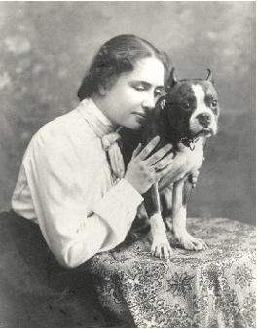

Thursday, June 30, 4:00 pm – 6:00 pm

at The Whole Person

3710 Main Street

Kansas City, MO 64111

(parking onsite & northwest corner of Baltimore & 37th)

Come out to **Connect** with others and to **discover resources** for DeafBlind!  Stay for 2 minutes or the full 2 hours!

Snacks, swag, and resources from area agencies available! Shared life experiences from presenters who are DeafBlind!

Bring your own Interpreter, or use a chat app onsite.  Two Floater Interpreters will be available for short periods of time.

Event sponsored by the Greater Kansas City DeafBlind Collaborative and The Whole Person.

RSVP is requested by June 23, 2022

Email [gkcdbc937@gmail.com](mailto:gkcdbc937@gmail.com)  with any questions.

(Photo is of Helen Keller as a young woman hugging her terrier dog Phi).

**Deaf and Hard of Hearing Experiences in Healthcare Summit on October 21, 2022**

During this one-day virtual summit, participants will be given tools, strategies and best practices to improve language and communication access, drive systemic change and, ultimately, improve the patient experience for Deaf, hard of hearing, DeafBlind and late deafened individuals.

This summit is designed for healthcare professionals and administrators, including individuals who work in the following areas: patient experience; language services; patient services; diversity, equity, inclusion and accessibility (DEIA); and risk management.

The summit agenda and additional pertinent information is listed at [www.2axend.com/DHHSummit](https://urldefense.com/v3/__http:/www.2axend.com/DHHSummit__;!!EErPFA7f--AJOw!UkFD60DF8JU8DlXFCXxCu2vMN99X_FCk8Tkco-RmOj6zS5bFiOSJBoP6n-rTMcz-efA6WbE$).

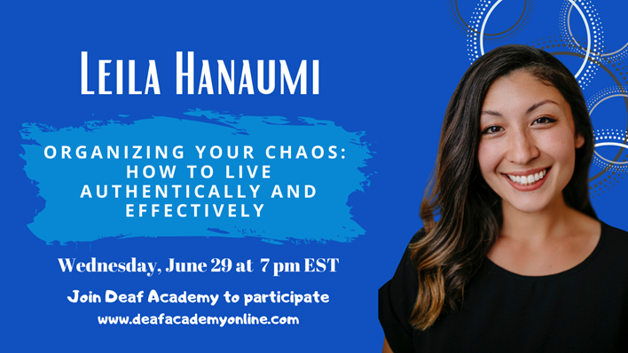Bio:  Leila (she/her) is a Deaf Asian writer and content creator with a multilayered skill set. She has spent over a decade managing branding and leading campaign strategy for Deaf-owned businesses and organizations. Several of her most memorable projects include SignVote – a campaign to make the Election accessible in ASL, “Human Actually” film series by Communication Services for the Deaf, and “Our Deaf Community” and “Beyoutiful” film series by Convo Communications.

**Webinar: Organizing Our Chaos: How to Live Authentically and Effectively -** Wednesday, June 29 at 7 pm EST

We all want happiness, and we’ve all experienced periods of happiness. But how can we have happiness that’s sustainable? The answer lies in the balance between the chaos and the calm. The unpredictable, raw, and fluid aspects of life can be beautiful, yet overwhelming. If we can learn to organize our thoughts, dreams, projects, and priorities, we can achieve sustainable happiness. Leila shares her personal stories of how she struggled to balance work and motherhood, and the tools she’s found along the way.

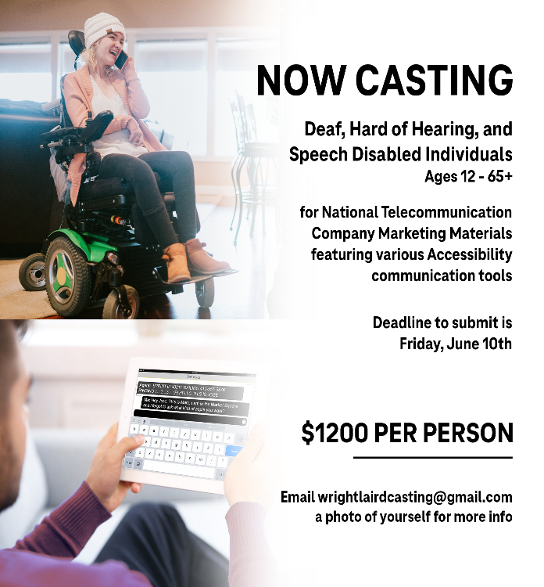**NOW CASTING!** Deaf, Hard of Hearing, and Speech Disabled Individuals Ages 12-65+ for National Telecommunication Company Marketing Materials featuring various Accessibility Communication tools. Photoshoot will take place in the Kansas City Metro and wider Missouri/Kansas area. July 11, 12 and/or 13, 2022. Model compensation: $1,200 per person.  Deadline to submit interest is Friday, June 10th. If interested, email [wrightlairdcasting@gmail.com](mailto:wrightlairdcasting@gmail.com) a photo of yourself.

[ID: Top Image - Young woman in wheelchair smiling while communicating on a wireless phone. Bottom Image – Person holding a tablet communicating using IP Relay services. Text on the image: NOW CASTING! Deaf, Hard of Hearing, and Speech Disabled Individuals Ages 12-65+ for National Telecommunication Company Marketing

Materials featuring various Accessibility Communication tools. Deadline to submit is Friday, June 10th. $1,200 per person. Email [wrightlairdcasting@gmail.com](mailto:wrightlairdcasting@gmail.com) a photo of yourself for more info]

**Child Protective Services and ASL Interpreter Webinars** will offered in June, July and August. To receive full credit, you will need to attend all three sessions offered each month. For more information, click here on the monthly links: June - [June CPS Courses](https://mcdhh.mo.gov/assets/sites/12/Educational-CPS-Flyer-June-22.pdf) July - [July CPS Courses](https://mcdhh.mo.gov/assets/sites/12/CPS-and-the-CPC-July-2022-Flyer.pdf) August - [August CPS Courses](https://mcdhh.mo.gov/assets/sites/12/Aug-2022-Flyer-TIIWC-2.pdf)



Join MCDHH on August 20, 2022 at Silver Dollar City Deaf and Hard of Hearing Awareness Day. If you are interested to be an interpreter for Deaf Awareness Day at Silver Dollar City on August 20, please email Amy Sue Guinn at [Amysue.Guinn@mcdhh.mo.gov](mailto:Amysue.Guinn@mcdhh.mo.gov) by June 15th.

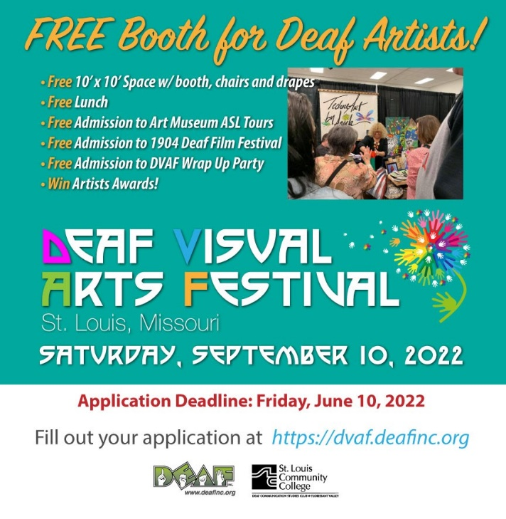

**Deaf Visual Arts Festival** will be Saturday, September 10, 2022. If you are a deaf artist and are interested in being an exhibitor the deadline is Friday, June 10, 2022. For more information, click here: <https://dvaf.deafinc.org>

For the first time ever, Kansas Relay and The Whole Person will be hosting Deaf Cultural Day at **Sporting Kansas City.**  There will be a big tent set up outside the stadium (inside the perimeter of the stadium area) for folks to mingle and hang out 2 hours before the game starts.    We are looking to have about 20 vendors at the event, if you are interested in being one, please reach out to myself and Micki Keck.    There’s no cost to being a vendor.  If you would like to contribute to the event, please contact me directly.  For more information, click here: [Sporting KC](https://mcdhh.mo.gov/assets/sites/12/SKC-Save-the-Date.pdf)

SHOW ME SUMMIT ON AGING & HEALTH 2022 We Are BETTER TOGETHER! SHOW ME SUMMIT ON AGING & HEALTH 2022 September 12-14, Kansas City, MO www.ma4web.org Missouri Association of Area Agencies on Aging and Age Positive Present the JOINT 17th Show Me Summit and the 7th Age Positive Conference September 12-14 | Fully in person at the Intercontinental Kansas City on the Plaza. For more information, click here: [Show Me Summit](http://www.ma4web.org/summit)

**JOB ANNOUNCEMENTS**

**Springfield Public Schools** is looking for an Educational Interpreter, ASL for the 2022 – 2023 school year. For more information, click her: [Educational Interpreter - ASL](https://urldefense.com/v3/__https:/spsmo.tedk12.com/hire/ViewJob.aspx?JobID=3252__;!!EErPFA7f--AJOw!Txoshlz03eL5MuGevDGZxwmAcwcEEk5Nmr0UCbnk1jYdHDySg360ZKidI4Y2OqggjOfSc3g$)

**Special School District** is hiring interpreters for the 22-23 school year. In addition to the privilege of contributing to the education and growth of students who are Deaf or hard of hearing, SSD’s interpreters  enjoy generous benefits including health/dental/vision,  access to a

retirement plan, paid time off, daily plan time to prepare for classes, and competitive compensation based on certification level and years of experience. Apply online. [Special School District Interpreter Position](https://urldefense.com/v3/__https:/www.applitrack.com/ssdmo/onlineapp/default.aspx?Category=Student*Support*Services*.YZaF3G5IFHk.link__;Kysj!!EErPFA7f--AJOw!RmJaWMfy9ySGR4UoapSnlZ2P5-YdWOVRP9bMmXy64XFhvoO_Wjl2EBhlJjA3QjIyL9mjBwo$).

If you have questions, please contact Wendy Jensen, [wajensen@ssdmo.org](mailto:wajensen@ssdmo.org) or 314-989-8139

