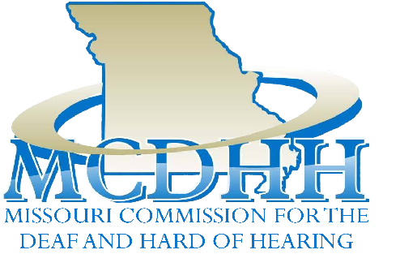

Upcoming Public Meeting:
MCDHH Commission
Meeting – June 9
Lohman’s Landing Building
100 Jefferson St., JC MO
10:00 a.m. – 2:00 p.m.

MCDHH E-News: May 20, 2022
3216 Emerald Lane, Suite B, Jefferson City
www.mcdhh.mo.gov V: (573) 526-5205; VP: (573) 298-6778

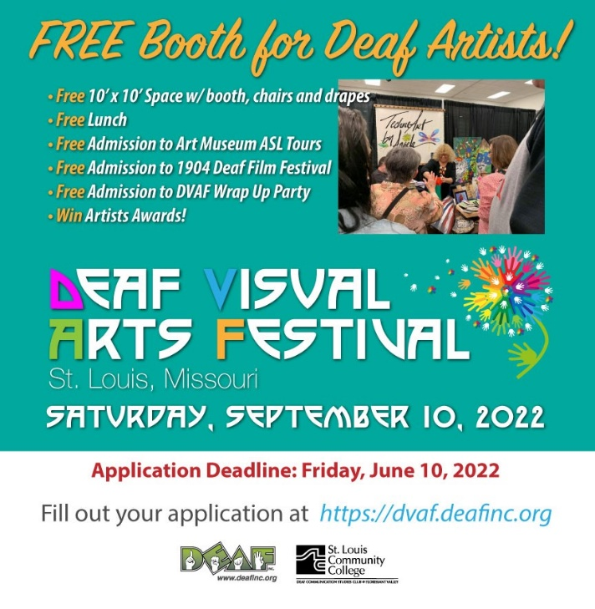
Deaf Visual Arts Festival will be Saturday, September 10, 2022. If you are a deaf artist and are interested in being an exhibitor the deadline is Friday, June 10, 2022. For more information, click here: https://dvaf.deafinc.org

Meredith Gray Green leads a virtual tour of CAM's exhibitions in American Sign Language (ASL) on Thursday, May 26, 2022 at 6:00 p.m. For more information, click here: Virtual ASL Tour

The Whole Person – Deaf Peer Support Group – Join us Tuesday, June 14 from 1:00 p.m. to 3:00 p.m. at The Whole Person Community Room, 3710 Main St., Kansas City, MO 6411. For more information, click here: Deaf Peer Support Group

For the first time ever, Kansas Relay and The Whole Person will be hosting Deaf Cultural Day at Sporting Kansas City. There will be a big tent set up outside the stadium (inside the perimeter of the stadium area) for folks to mingle and hang out 2 hours before the game starts. We are looking to have about 20 vendors at the event, if you are interested in being one, please reach out to myself and Micki Keck. There’s no cost to being a vendor. If you would like to contribute to the event, please contact me directly. For more information, click here: Sporting KC

Silver Dollar City Deaf Awareness Day is Back! Join us on Saturday, August 20, 2022. For more information, click here: Silver Dollar City
SHOW ME SUMMIT ON AGING & HEALTH 2022 We Are BETTER TOGETHER! SHOW ME SUMMIT ON AGING & HEALTH 2022 September 12-14, Kansas City, MO www.ma4web.org Missouri Association of Area Agencies on Aging and Age Positive Present the JOINT 17th Show Me Summit and the 7th Age Positive Conference September 12-14 | Fully in person at the Intercontinental Kansas City on the Plaza. For more information, click here: Show Me Summit

Missouri Interpreter Conference –
The 2022 Don’t Limit Your Challenges. Challenge Your Limits conference will be held October 7 -9, 2022 at the Tan Tar A Lake Resort - “Margaritaville”. MCDHH is excited to announce the keynote speaker, Maricar Marquez. Ms. Marquez is a DeafBlind supervisor of the Independent Living Department at the Helen Keller National Center for DeafBlind Youths and Adults (HKNC) in Sands Point, NY. Watch for the conference mailer coming out soon.

JOB ANNOUNCEMENTS:

Special School District is hiring interpreters for the 22-23 school year. In addition to the privilege of contributing to the education and growth of students who are Deaf or hard of hearing, SSD’s interpreters enjoy generous benefits including health/dental/vision, access to a retirement plan, paid time off, daily plan time to prepare for classes, and competitive compensation based on certification level and years of experience. Apply online. Special School District Interpreter Position.
If you have questions, please contact WendyJensen, wajensen@ssdmo.org or 314-989-8139

