MCDHH E-News: January 21, 2022
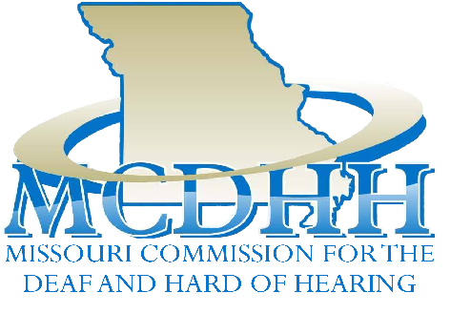

Upcoming Public Meeting:
MCDHH Commission Meeting
March 10, 2022
Details TBA

3216 Emerald Lane, Suite B, Jefferson City
www.mcdhh.mo.gov V: (573) 526-5205; VP: (573) 298-6778
Call For Planning Committee Members for the MCDHH Interpreter Conference
- Are you a member of the Deaf, HOH, DeafBlind or interpreter community?
- Do you enjoy organizing and planning events?
- Do you want to know a behind the scenes look at MCDHH?
- If yes to any of the questions above, then you ARE the RIGHT PERSON for our Committee!
If interested, please send your contact information to Laurie Lister at Laurie.Lister@MCDHH.MO.GOV or call at (573) 526-5205.
Instagram and Twitter! MCDHH now has Instagram and Twitter. Please follow our page MOCDHH on Instagram and Twitter to keep updated!
Join the MCDHH Team: Now Hiring a MICS Coordinator
Are you looking for an opportunity to work in a highly visible and respected state agency? Are you interested in approving top quality workshops and assisting in rater training sessions? Then you should join our team! MCDHH is currently looking for applicants to fill the position of MICS Coordinator. Click here to learn more

Children’s Clear Masks Available for DHH Organizations
MCDHH has child-sized clear masks to provide to Deaf or hard of hearing children, and children who interact with adults with hearing loss. If your organization is interested in receiving a larger quantity of masks, please reach out to Laurie Lister at (573) 526-5205 or Laurie.Lister@mcdhh.mo.gov.

Community Announcements
- Wonderland Camp is hosting a SILENT WEEKEND on March 18-20, 2022. This will be a deaf culture immersive experience to expand your nonverbal communication skills and build on your American Sign Language vocabulary. To learn more, visit Silent Weekend.pdf

- William Woods University Honors Program is conducting undergraduate research concerning the personality of American Sign Language interpreters and other jobs. If you are able, please fill out this short survey and pass it along to other interpreters. Thank you for your time and consideration! https://forms.gle/FnkKpw6RWBuy9c5HA
- Relay Missouri Advisory Committee - The next RMAC meeting is April 12th at 10am. Whether the meeting will be in person or virtually will be decided closer to date. There are two Committee vacancies - the speech impaired and hearing positions. If you know of anyone who would be interested in serving on the RMAC please have them get in touch with.

Contact: April Mason-Donovan amasondonovan@stlcc.edu or John Van Eschen john.vaneschen@psc.mo.gov
- IDRT – Institute for Disabilities Research and Training, Inc is offering my ASL Tech.com program. Here are some highlights:
myASLTech is a unique online toolkit of 10 assistive technologies that enable users to:
* Efficiently create and archive ASL-enhanced educational materials and quizzes
* Pair text with sign graphics and video in real time to support reading
* Build and cloud-share creations with other myASLTech Colleagues
* Play games that reinforce ASL and English literacy
* Read original children’s stories with ASL video translations and voiceover
myASLTech contains a central growing database of over 11,500 words, phrases, symbols, idioms and numbers and their representative sign language graphics and video clips. As the database expands, so do the capabilities
of each assistive technology tool.
Training and technical assistance are FREE!
To learn more, visit: https://www.idrt.com/asltech_home.php
Here is the University of Northern Colorado’s logo. It has the University name in blue and the word IRIS in yellow with the words Improving Rural Interpreter Skills in blue. There is a light blue and purple Iris petal on the side on the word IRIS.
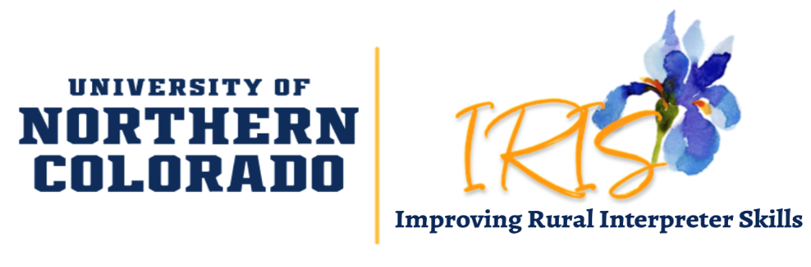
- Still time to apply! IRIS (Improving Rural Interpreter Skills) Project Instructional Team There is still time to apply to be a part of the IRIS instructional team (quick link to the application below)! For more information, including a recording of an informational Q&A session, visit the IRIS Instructional Candidates webpage. Recruitment for IRIS participants/students
will be in Spring 2022! See more about IRIS on our website, Facebook and Instagram pages.
- National Deaf Center is requesting participants to be involve in a single-visit interview (in person or on zoom) to recount their experiences during speech-language therapy, physical therapy and occupational therapy to gain their perspectives and inform future clinical decisions. Click the attached flyer Volunteers wanted for a Research study (003).pdf to view the inclusion criteria, program description and the contact information.

- Gallaudet University IRB Approval needs participants for a study on a novel ASL-based measure of cognitive functioning. To participate: scan QR code or click Study Flyer.pdf to access study description and to complete eligibility screening or contact Erin Timperlake – Primary Researcher ASLCogStudy@gallaudet.edu

- Department of Mental Health Division of Developmental Disabilities is looking for a DeafBlind PCA. This position would be working with a DeafBlind client in the South Kansas City area. Qualified candidates should be fluent in Tactile ASL, be available 3 hours a day Monday-Friday while providing evening personal assistance support. Interested in this position? Contact Sharon Hall at (816) 889-3422 or Sharon.Hall@dmh.mo.gov

- RTI International and The Lancet - Researchers are working on a study to address stigma associated with deafness and loss of hearing. They need the opinions and perspectives of individuals who are deaf or have a loss of hearing so we can help health professionals, policymakers, and researchers understand the unique social obstacles of this group of individuals. Click here to learn more.

