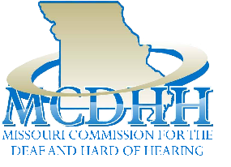

**E-News**

**April 28, 2023**

3216 Emerald Lane, Suite B, Jefferson City

www.mcdhh.mo.gov V: (573) 526-5205; VP: (573) 298-6778

**HB 106/SB 340**

**2023 MCDHH Commission Meetings**

**Thursday, June 22**

The Lohman Building, 100 Jefferson Street, Jefferson City, MO

10:00 a.m. – 2:00 p.m.

**Thursday, October 19**

Address TBA

Jefferson City, MO

Becky Davis, Executive Director of MCDHH

The Deaf Community, MoAD, The Whole Person and MCDHH are trying to make the very last second count!

HB106 is now with the Majority Floor Leader, Representative Jonathan Patterson. He is responsible for scheduling the bills to be put on the House calendar for a Floor Vote. In support of this bill, if you have a moment and can send an email to him ([Jonathan.Patterson@house.mo.gov](mailto:Jonathan.Patterson@house.mo.gov) )asking him to **consider moving HB106 to the House Floor for a vote**. If you are from the Lee’s Summit area, that is his district, let him know you are from the area. That would be fantastic.

AND, if you are local to the Mid-Mo area and can stop in for a visit, his office is at the capitol Rm 302A. You will probably meet one of his staff, but that is fine. Let the staff know what you would like. There may not be an interpreter available, I often use my phone to type what I want to say to follow up with an email.

MCDHH shared a posting from MoAD that also includes this information as well.

**DEAF AWARENESS DAYS or DEAF DAYS...Information Coming Soon**

Our staff are all always looking for opportuntities for Deaf Awareness or Deaf Days at different locations. If you see an event or know of a location you think would benefit the Deaf/Hard of Hearing/DeafBlind community, please share that information with our office and we will follow up.

**Friday, June 9th** there will be a Deaf Day at the St. Louis Zoo. There will be a schedule available for different events that will have sign language interpreters. Staff Interpreter, Amy Sue Guinn is collaborating with the St. Louis Zoo and working out the details. Although admission into the zoo is free, if you want to catch any of the shows, they have their own prices that can be seen here: <https://stlzoo.org/>

**Saturday, July 15th, 2023**. Come experience the historical Missouri State Penitentiary tours. The first tour, a 3-hour ($35 & must be 10+ years of age) at 9:00am or the second tour, a 2-hour ($25 & must be 6+ years of age) tour at 1:00pm takes you into the facility up and down passageways and staircases. Beware, this is **physical** tour and it will be in the middle of July with no AC. If you love history and are curious, come join us. ASL interpreters will be provided. We have to have at least 30 people, but there is a limit of 35 reservations for each tour, so contact Amber Carter soon and get your name on the list! Let Amber know on which tour you want to go. [Amber.Carter@mcdhh.mo.gov](mailto:Amber.Carter@mcdhh.mo.gov) Payment will be on-site before the tour & there is a waiver to sign and bring...Oh, did we forget to say that the prison has a reputation for being haunted?....and is dubbed ‘the bloodiest 47 acres in America” ☺

For more Missouri history before or after the prison tour OR if you would just like to stay in the cool AC, there will be 11:00am and 2:00pm tours of the Missouri State Capitol with ASL interpreters provided. We have to have at least 25 folks to have a tour. Let Amber Carter know what time is best for you! [Amber.Carter@mcdhh.mo.gov](mailto:Amber.Carter@mcdhh.mo.gov) There is no cost associated with this tour.

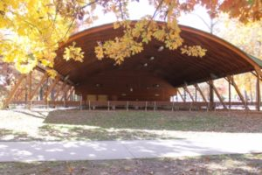After all that, come join us at Memorial Park Pavilion for a Barbeque and social. A meal of hotdogs or hamburgers, sides, and drinks will be available for $8.00. Finish off your day with us. Proceeds will go to the Hearing Aid Distribution Fund at MCDHH.

* * * * * * * * * * * * * * * * * * * * * * * * * * * * * * * * * * * * * * ** * * * * * * ** * * * * *

**MCDHH MICS Coordinator, Shanda Miller**: June 10, 2023 Workshop Announcement!!!

Online Payment: [Interpreters - MO Commission for the Deaf and Hard of Hearing](https://mcdhh.mo.gov/interpreters/) (Scroll down to the ONLINE PAYMENT OPTION > here > YES > Make a one-time payment > Payment Type-Workshop Fees > Your First and Last Name > Total Amount you wish to pay > *check out* *with card information. Email Registration information (found on the form following the announcement) to Shanda Miller to indicate which workshop you would like to attend.*

For check or money order: ‘BCI Fund’ and mail to 3216 Emerald Lane, Suite B, Jefferson City, MO 65109 and mail with a completed Registration Form.

Please either complete the registration form following the flyer and send an image of it to Shanda Miller OR type out the requested information and email Shanda Miller to let her know which workshops you wish to attend and have paid for.

For forms or questions: [Shanda.Miller@mcdhh.mo.gov](mailto:Shanda.Miller@mcdhh.mo.gov)

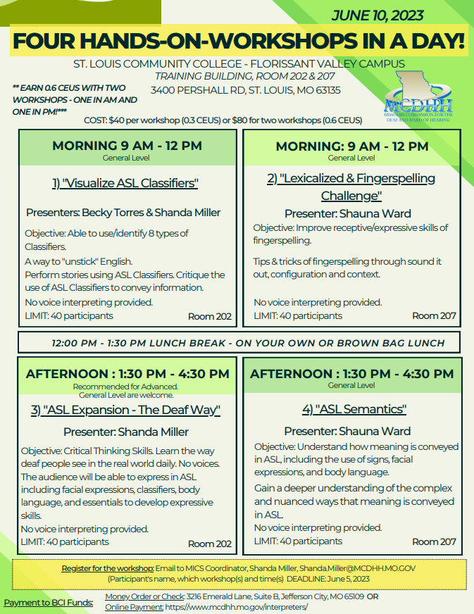

For Registration and Payment instructions, go to the beginning of the MICS Coordinator announcement. Thank you!

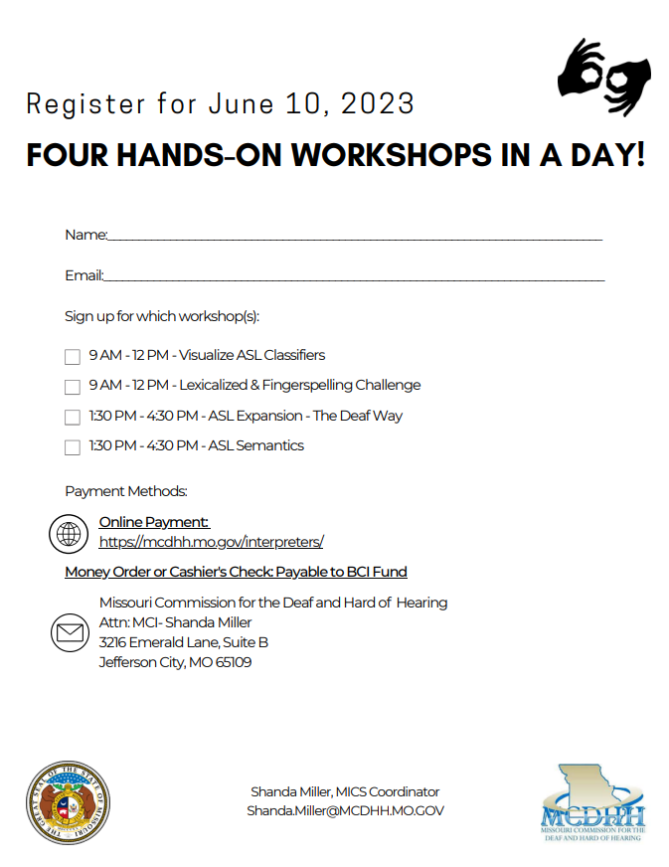

============================================================================

MMDC MOTHER’S DAY event on May 13th

William Woods Univ, Burton Bdg, Rm 006

Fulton, MO 10:00-5:00

Salad with dressings and croutons will be provided.

Please bring food and vegetables.

With a dish $5.00/Without a dish $7.00

A prize for MOTHER’S DAY/GRANDMOTHER’S DAY clothing will be given.

Any questions contact Mary Kistner at mryntt@yahoo.com

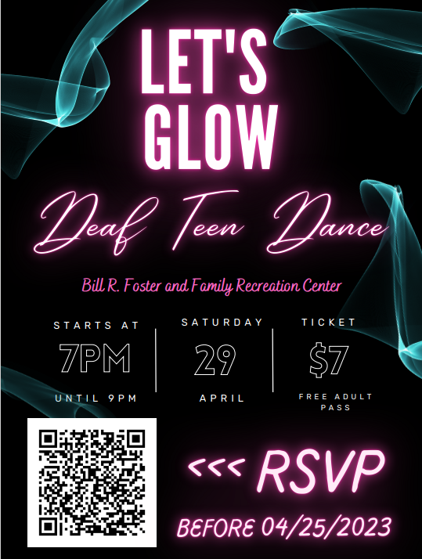



<https://www.youtube.com/watch?v=Kur1tStcO0I>

<https://www.nad.org/2023-nltc/>

**HKNC Mental Health Training Series**

**When:** Weekly in May 2023

**Time:** Wednesdays 5:00 PM-7:00 PM CST

**Where:** Zoom

Helen Keller National Center is excited to announce a webinar series on Mental Health services for individuals who are DeafBlind.  The goal is to increase access to mental health resources, overall awareness and understanding of the success and struggles within the diverse DeafBlind population. Interpreting support will be available. CEUs will be offered.  
**HKNC Mental Health Training Series**  
Weekly webinars topics will address:

Week 1:  DeafBlind Mental Health for Professionals

Week 2:  DeafBlind Mental Health for VR Counselors

Week 3:  Mental Health for DeafBlind Individuals

Week 4:  DeafBlind Mental Health for Families

Week 5:  DeafBlind Mental Health for Interpreters

If you are interested and would like further information, please fill out the link below.  Questions?  Email us at [pld@hknc.org](mailto:pld@hknc.org)

[https://survey.alchemer.com/s3/7203293/Mental-Health-Training-Series-Pre-Registration](https://urldefense.com/v3/__https:/survey.alchemer.com/s3/7203293/Mental-Health-Training-Series-Pre-Registration__;!!EErPFA7f--AJOw!GCVp9_GzU1v6D5lScFcijjhbZ_XdN-NpN6SBx0AH6n2oZX5GIR78dnfxhKpeyhXkvvsaY_nvuTJG-fmU4c0Dv53sIvas$)

mentors,

MCDHH WANTS YOU

MCDHH is looking into setting up some type of Mentorship opportunity/program. We are beginning to gather names for people fluent in ASL who are interested in working as MENTORS for individuals who are learning ASL. Currently, payment for mentorships would be handled between the parties involved. CEUs can be earned for approved before mentorships for both mentors and mentees.

Please contact our agency if this is something you find interesting.

[Shanda.Miller@mcdhh.mo.org](mailto:Shanda.Miller@mcdhh.mo.org)

Some of this might overlap, but for those of you who are interpreters who would be interested in serving as mentors to aspiring interpreters or interpreters who are focused on a particular skill, we would also like to have your name.

[AmySue.Guinn@mcdhh.mo.org](mailto:AmySue.Guinn@mcdhh.mo.org)

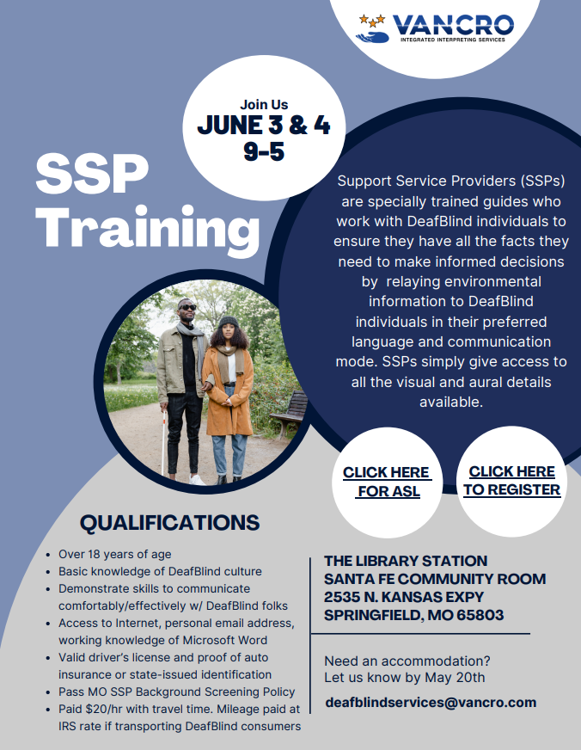

[RSVP (airtable.com)](https://airtable.com/shrB279zfKUiOwmBV)

[Support Service Provider (SSP) Training Announcement - YouTube](https://www.youtube.com/watch?v=EIu-M6tHofk)

**MoAD 48th Biennial Conference 2023**

**LOOK UP! LOOK FORWARD! LOOK AROUND!**

MoAD’s Strategic Planning for the 21st Century – 2024 to 2029

August 10-13, 2023

Columbia, MO

Holiday Inn Executive Center

**Combo Tickets**

**ON SALE NOW**

Combo ticket Form: <https://www.moadeaf.org/_files/ugd/e6b87d_bd3d266b36704b018f5fd3f274073e30.pdf>

For advertising, sponsorship and exhibitor information: <https://www.moadeaf.org/_files/ugd/e6b87d_3c09c474acf144b99b7b76e17ddbca1f.pdf>

Exhibit Space Rental: <https://www.moadeaf.org/_files/ugd/e6b87d_3adf59dcf55543859b359f221aa7db4c.pdf>

For all other details: <https://www.moadeaf.org/blank>

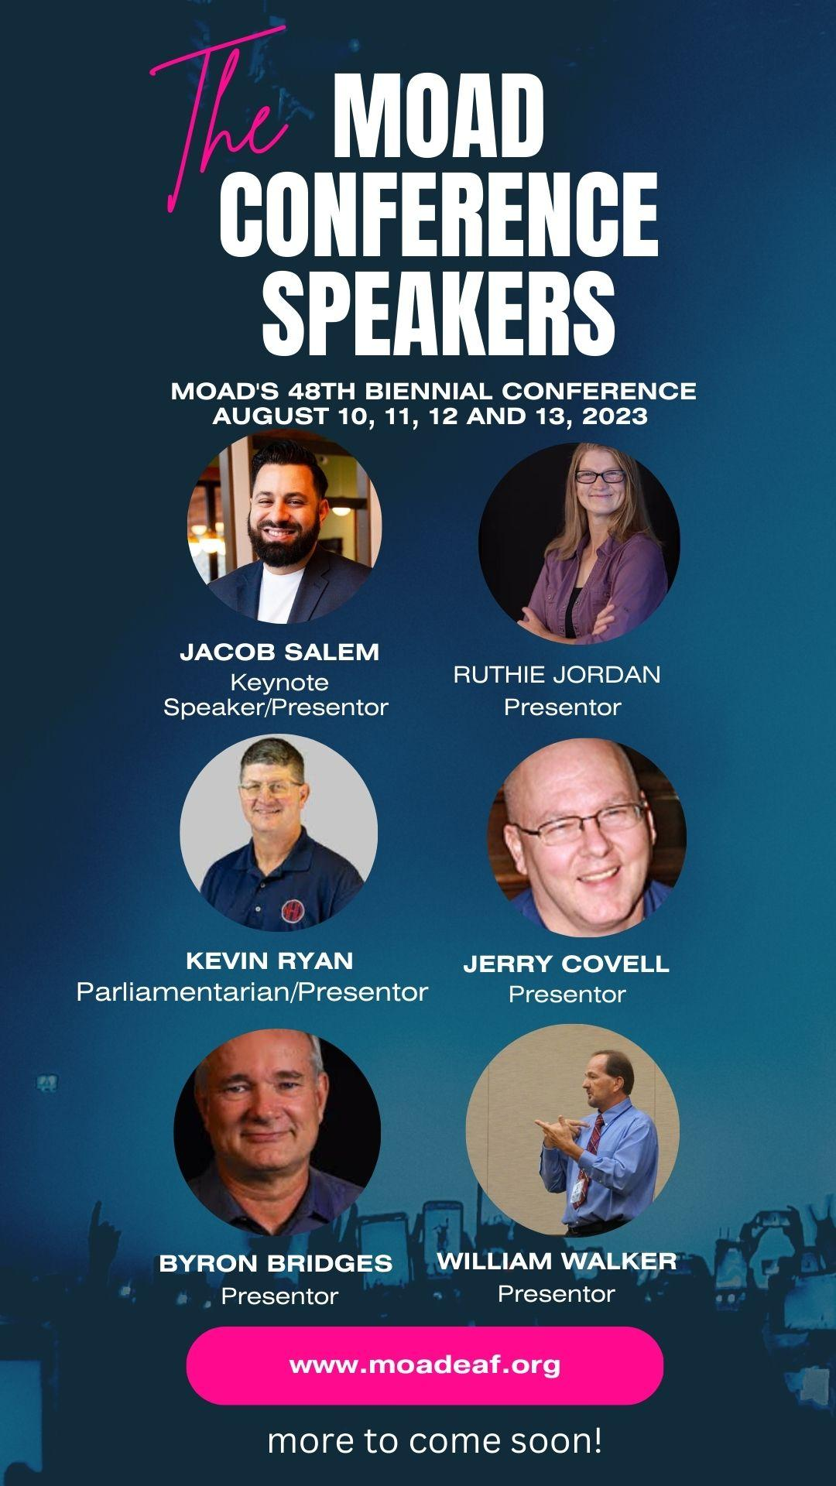

=====**EMPLOYMENT OPPORTUNITIES**===========================================

**MCDHH is seeking an**

**Office Support Specialist**

**Located in Jefferson City, MO**

Check it out: <https://mocareers.mo.gov/hiretrue/ce3/job-board/5effe9b2-4b89-494b-ac76-c45e25190768>

Become part of the MCDHH Team!

- - - - - - - - - - - - - - - - - - - - - - - - - - - -

**Parkway School District (St. Louis), ASL Teacher Positions:**

[https://www.applitrack.com/pkwyk12/onlineapp/default.aspx?Category=Teacher+-+Other](https://urldefense.com/v3/__https:/www.applitrack.com/pkwyk12/onlineapp/default.aspx?Category=Teacher*-*Other__;Kys!!EErPFA7f--AJOw!EtXkZUk4MWLc-FlRxAH8TITfWMDAR6kXXo27onME6gKuB_wSbgxb_26a-PmstY6IQzpDQr7XFAAsdD7F61CXpDYTJ6hLDZI$)

- - - - - - - - - - - - - - - - - - - - - - - - - - - -

SORENSON is looking for good employees:

Field Installer/Trainer for the Springfield, MO area: <https://recruiting2.ultipro.com/SOR1001SORE/JobBoard/1fe5e40e-4e0c-4b11-86e3-9a8e1f396263/OpportunityDetail?opportunityId=63407e37-d120-4863-84da-48e71fe941a9>

Field Installer/Trainger for the St. Louis Area (2):

<https://recruiting2.ultipro.com/SOR1001SORE/JobBoard/1fe5e40e-4e0c-4b11-86e3-9a8e1f396263/OpportunityDetail?opportunityId=1062d60a-4186-45a3-85d3-08332362d381>

- - - - - - - - - - - - - - - - - - - - - - - - - - - -

**Vocational Rehabilitation Counselor:**

Do you know someone who is skilled in American Sign Language (ASL)? Please help VR find great candidates for the Jefferson City office by sharing this link on your social media and with anyone you feel may eligible and interested. Do not be discouraged by the master’s degree as we will consider a bachelor’s degree for the right candidate. *This posting will remain open until filled.*

[https://mocareers.mo.gov/hiretrue/ce3/job-board/5effe9b2-4b89-494b-ac76-c45e25190768/95fa2d00-5fc5-4ee4-8924-e10c1eb7a5a9?jb=true](https://urldefense.com/v3/__https:/gcc02.safelinks.protection.outlook.com/?url=https*3A*2F*2Fmocareers.mo.gov*2Fhiretrue*2Fce3*2Fjob-board*2F5effe9b2-4b89-494b-ac76-c45e25190768*2F95fa2d00-5fc5-4ee4-8924-e10c1eb7a5a9*3Fjb*3Dtrue&data=05*7C01*7Crobert.cooper*40ks.gov*7Cbe2a7d6f8b6f4c70265e08db26f99830*7Cdcae8101c92d480cbc43c6761ccccc5a*7C0*7C0*7C638146625686254074*7CUnknown*7CTWFpbGZsb3d8eyJWIjoiMC4wLjAwMDAiLCJQIjoiV2luMzIiLCJBTiI6Ik1haWwiLCJXVCI6Mn0*3D*7C3000*7C*7C*7C&sdata=ipwNNQH0H0M*2BfrkTG*2BabQeOdFEP58TVvViLRdqJWPT8*3D&reserved=0__;JSUlJSUlJSUlJSUlJSUlJSUlJSUlJSUlJSUlJQ!!EErPFA7f--AJOw!GxAPL3_VomHTl4dytJaxVbuxUjx6AEwEln6Df-6Uzbcn6UcJGvTR7gIhAH5-wqkW2lSUFAI5yjmLvW2NsOM5Koz4IJJEhqE$)

- - - - - - - - - - - - - - - - - - - - - - - - - - - -

**VocoVision is hiring Sign Language Interpreters** in Missouri for fully remote, school-based positions. Partner with VocoVision as an Educational Sign Language Interpreter to help children gain access to the critical interpreter services they need to succeed. If you are interested in working with us or would like additional information, get connected to our team by reaching out to [Ian.Leupold@VocoVision.com](mailto:Ian.Leupold@VocoVision.com).

- - - - - - - - - - - - - - - - - - - - - - - - - - - -

**OPPORTUNITY AT MSD:**

Check out MoCareers.mo.gov for positions open at the Missouri School for the Deaf: <https://mocareers.mo.gov/hiretrue/ce3/job-board/5effe9b2-4b89-494b-ac76-c45e25190768>

* Home School Coordinator (closes 5/31)
* LPN (closes 5/15)
* Pyschologist (closes 5/15)
* Residential Advisor (closes 5/31)
* School Interpreter (closes 5/31)
* School Support Associate (closes 5/31)
* Speech-Language Pathologist (closes on 5/15)
* Teacher-Art (closes on 5/15)
* Teacher-Elementary (closes on 5/15)
* Teacher-Life Skills (closes on 5/15)
* Teacher-Math (closes on 5/15)
* Teacher-Science (closes on 5/15)
* Teacher Aide (closes on 5/31)